**Financial Forecast Sandesh Brand 4**

**Data Analysis:**

1. **Dataset taken: trainv.csv**

The dataset contains 66 instances with 10 attributes including the class.

For Each Attribute: (all numeric-valued)

1. Generic LookupKey
2. Segment 2Sandesh Brand 1MobileLeopardClosing Base
3. Segment 2Sandesh Brand 1MobileLeopardLeavers
4. Segment 2Sandesh Brand 1MobilePantherClosing Base
5. Segment 2Sandesh Brand 1MobilePantherLeavers
6. Segment 2Sandesh Brand 1MobilePantherGross Adds
7. Segment 2Sandesh Brand 1MobileHyenaClosing Base
8. Segment 2Sandesh Brand 1MobileHyenaLeavers
9. Segment 2Sandesh Brand 1MobileHyenaGross Adds
10. Segment 2Sandesh Brand 1MobilePanther - Leopard - HyenaTotal Revenue

Model used to predict/forecast the future values is SARIMA model

**SARIMA Model**

Up until now, we have not considered the effect of seasonality in time series. However, this behavior is surely present in many cases, such as gift shop sales, or total number of air passengers.

A seasonal ARIMA model or SARIMA is written as follows:

SARIMA (p,d,q)(P,D,Q)m

You can see that we add P, D, and Q for the seasonal portion of the time series. They are the same terms as the non-seasonal components, by they involve backshifts of the seasonal period.

In the formula above, *m* is the number of observations per year or the period. If we are analyzing quarterly data, *m* would equal 4.

**Steps involved in Project:**

**Step 1:** Initializing the libraries

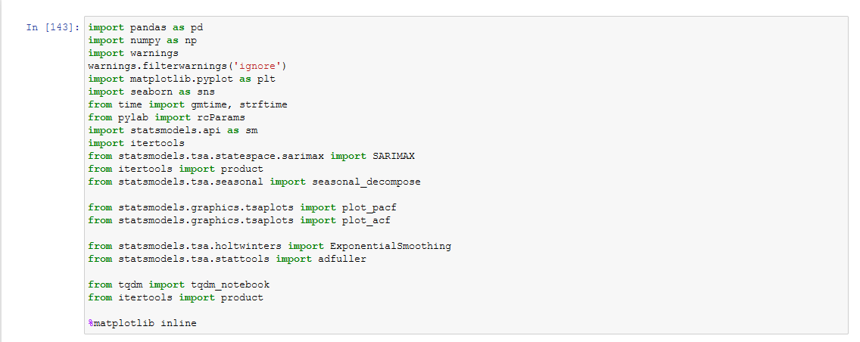

**Step 2:** Reading the CSV file using panda library

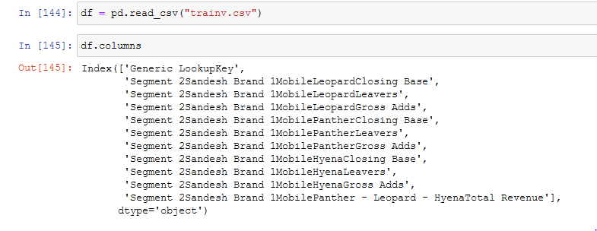

**Step 3:** Checking whether the columns which are to be predicted are Stationary or Non-Stationary

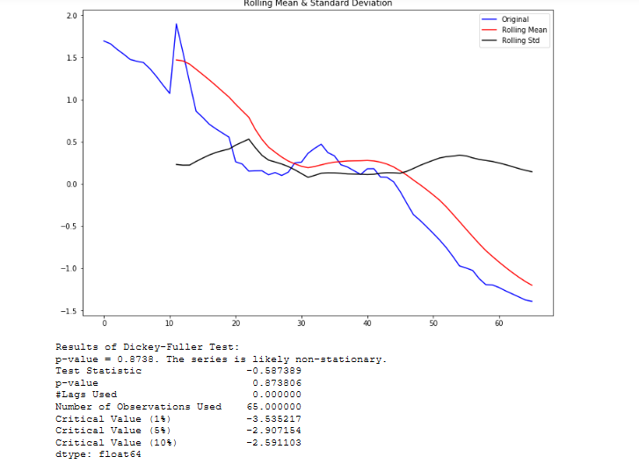

**Step 4:** Convert the Non-Stationary column to Stationary (Note: Check p-value i.e. p-value<= 0.01)

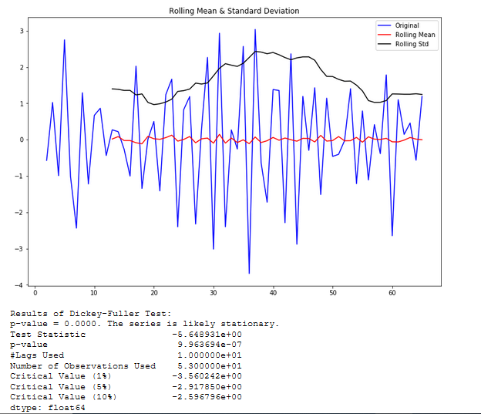

**Step 5:** Plot the Auto-Correlation and Correlation

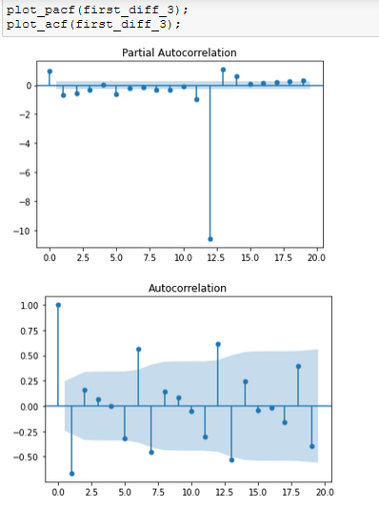

**Step 6:** Finding the best optimal values of AIC for p,d,q values for SARIMA model

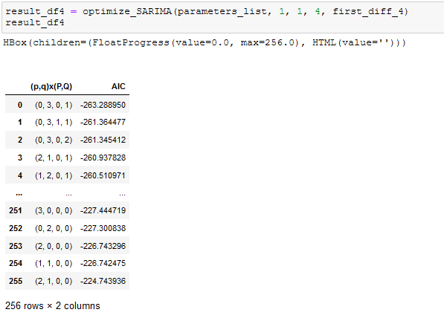

**Step 7:** Pass the optimal p,d,q values to SARIMA model for fitting

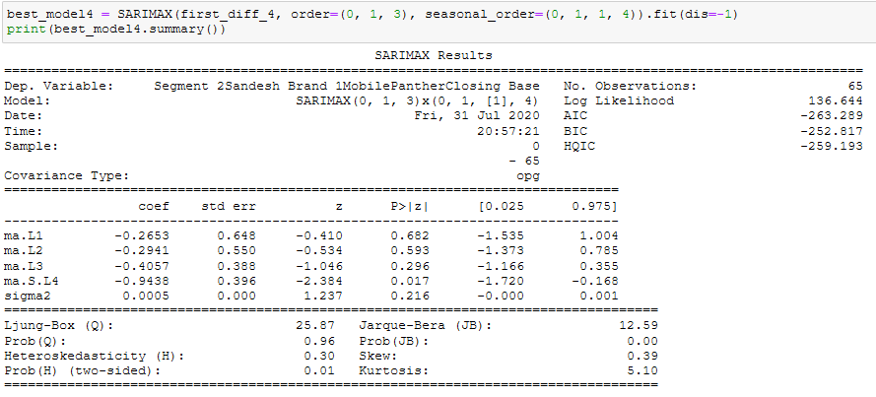

**Step 8:** Plot the SARIMA model

Here, the predicted values are represented by red lines and the actual values are indicated by blue lines.

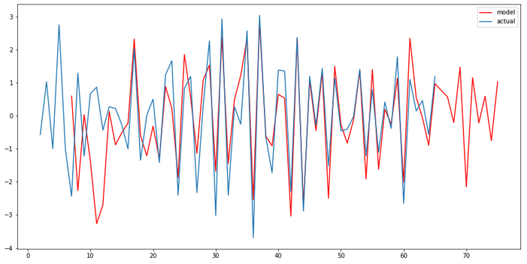

**Step 9:** You can see the predicted/forecasted values in the code as shown in the screenshot for duration between October 2019 - September 2020

